Smart home energy monitoring system

Simulates IOT based household energy monitoring

Inputs:device usage data,IOT sensors

Output:real timegraphs,peak demand detection

Libraries:pandas,matplotlib,mqtt

Application:smart grid,home automation

Source code:

# using pandas

import pandas as pd

devices={

'devices':['devices 1' ,'device 2','device 3','device 4'],

'usage':[7,8,2,18],

'iot_sensors':[1,2,3,4]

}

df=pd.DataFrame(devices)

df['total_usage']=df['usage']+df['iot_sensors']

print(df)

import matplotlib.pyplot as plt

time=[2,4,6,8]#sec

device_usage_data=[10,20,30,40]

plt.plot(time,device_usage_data,marker='h')

plt.xlabel('time(sec)')

plt.ylabel('device usage')

plt.title("device usage vs time")

plt.show()

plt.plot(time,iot_sensors,marker="h")

plt.xlabel('time(sec)')

plt.ylabel('iot sensors')

plt.title("iot sensors vs time")

plt.show()

plt.plot(device_usage_data,iot_sensors,marker='h')

plt.xlabel('device usage')

plt.ylabel('iot sensors')

plt.title("device usage vs iot sensors")

plt.show()

Output:

devices usage iot_sensors total_usage

0 devices 1 7 1 8

1 device 2 8 2 10

2 device 3 2 3 5

3 device 4 18 4 22

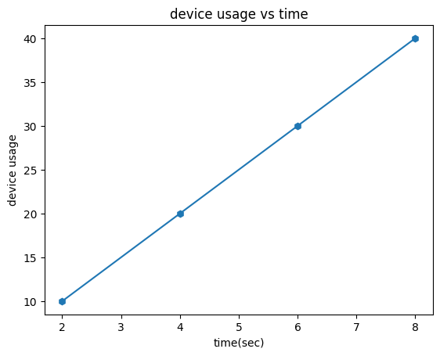

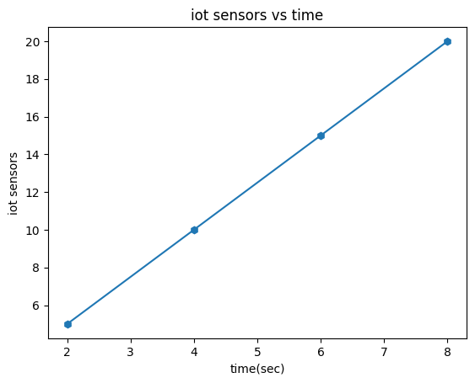

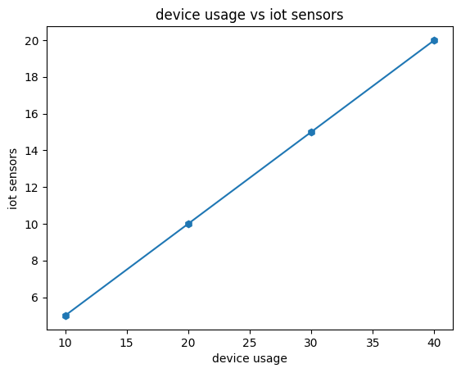

Conclusion :

An IoT-based household energy monitoring system offers a cost-effective and efficient way to track and manage energy consumption, promoting conservation and potentially reducing costs. By connecting appliances and devices to the internet, the system enables real-time monitoring, remote control, and data analysis, empowering users to make informed decisions about their energy usage.